- Explain in detail about HTTP Request and Response
  - HTTP Request and Response, HTTP Request Format, HTTP Response Format, Request URL, Request Method, Content-Type, User-Agent
    - Ref - https://en.wikipedia.org/wiki/Hypertext_Transfer_Protocol
HTTP Request and Response
    - Introduction
    - HTTP (HyperText Transfer Protocol) is a communication protocol used for data exchange between a client and a server over the web. It follows a request-response model, where the client sends a request and the server responds with the requested data or status.

    - HTTP Request
    - Definition
    - An HTTP Request is a message sent by the client (such as a web browser or application) to the server to request a resource or perform an operation.

    - HTTP Request Format
    - An HTTP request consists of four main parts:
    - Request Line
    - Headers
    - Blank Line
    - Message Body (optional)

    - Example of HTTP Request
    - GET /countries HTTP/1.1
    - Host: example.com
    - User-Agent: Mozilla/5.0
    - Content-Type: application/json

    - Components of HTTP Request
    - 1. Request Line
    - The request line contains:
    - HTTP Method (GET, POST, etc.)
    - Request URL
    - HTTP Version
    - Example:
    - GET /countries HTTP/1.1

    - 2. Request Method
    - The request method specifies the action to be performed on the resource.
    - Common methods:
    - GET: Retrieve data from the server
    - POST: Send data to the server
    - PUT: Update existing data
    - DELETE: Remove data

    - 3. Request URL
    - The request URL specifies the location of the resource on the server.
    - Example:
    - https://example.com/countries

    - 4. Headers
    - Headers provide additional information about the request.
    - Examples:
    - Content-Type: Specifies the format of data being sent
    - User-Agent: Identifies the client making the request

    - 5. Content-Type
    - The Content-Type header indicates the media type of the request body.
    - Examples:
    - application/json
    - text/html

    - 6. User-Agent
    - The User-Agent header identifies the client application, such as a browser or API tool.
    - Example:
    - User-Agent: Mozilla/5.0

    - 7. Message Body (Optional)
    - The body contains data sent to the server, typically used in POST or PUT requests.
    - HTTP Response
    - Definition
    - An HTTP Response is the message sent by the server back to the client after processing the request. It contains the status of the request and the requested data.

    - HTTP Response Format
    - An HTTP response consists of:
    - Status Line
    - Headers
    - Blank Line
    - Message Body

    - Example of HTTP Response
    - HTTP/1.1 200 OK
    - Content-Type: application/json

    - {
    - "code": "IN",
    - "name": "India"
    - }

    - Components of HTTP Response
    - 1. Status Line
    - The status line contains:
    - HTTP Version
    - Status Code
    - Status Message
    - Example:
    - HTTP/1.1 200 OK

    - 2. Status Codes
    - Status codes indicate the result of the request.
    - Common status codes:
    - 200 OK: Request successful
    - 201 Created: Resource created
    - 400 Bad Request: Invalid request
    - 404 Not Found: Resource not found
    - 500 Internal Server Error: Server error

    - 3. Headers
    - Response headers provide additional information about the server and response data.
    - Example:
    - Content-Type: application/json
    - 4. Message Body
    - The body contains the actual data returned by the serve

- Explain the need and benefits of RESTful Web Services
  - REST stands for REpresentational State Transfer, lightweight, maintainable, scalable, underlying protocol is HTTP; composed of resources, verbs, header, body, response status code, client-server technology
    - Ref - https://www.chakray.com/advantages-of-rest-api/
REST (REpresentational State Transfer) is an architectural style used for designing networked applications. RESTful Web Services use standard HTTP protocols to enable communication between client and server systems. They are lightweight, scalable, and easy to maintain, making them widely used in modern web applications and APIs.

Need for RESTful Web Services
RESTful Web Services are required due to the following reasons:
- Platform Independence
Different applications may be developed using different technologies. REST enables communication between them regardless of platform or language.
- Web-Based Communication
Modern applications rely heavily on web communication. REST uses HTTP, which is universally supported.
- Scalability Requirements
Applications with a large number of users need scalable solutions. REST supports stateless communication, making scaling easier.
- Integration of Systems
REST APIs help integrate multiple systems such as mobile apps, web apps, and third-party services.
- Simplification of Client-Server Interaction
REST simplifies communication using standard methods like GET, POST, PUT, and DELETE.

Key Features of REST
RESTful Web Services are composed of the following components:
- Resources: Represent data or objects (e.g., users, countries)
- Verbs (HTTP Methods): Actions performed on resources (GET, POST, PUT, DELETE)
- Headers: Provide metadata such as Content-Type
- Body: Contains data sent to or received from the server
- Response Status Codes: Indicate success or failure of a request
- Client-Server Architecture: Separation of frontend and backend

Benefits of RESTful Web Services
1. Lightweight
REST uses simple HTTP protocols and commonly JSON format, making it faster and less complex compared to other approaches like SOAP.
2. Scalability
REST is stateless, meaning each request is independent. This allows servers to handle large volumes of requests efficiently.
3. Maintainability
Separation of client and server ensures that changes in one do not affect the other, making the system easier to maintain.
4. Flexibility
REST supports multiple data formats such as JSON, XML, and plain text, allowing flexibility in data exchange.
5. Performance
Due to caching and stateless operations, RESTful services provide better performance and faster response times.
6. Easy Integration
REST APIs can be easily integrated with web applications, mobile apps, and third-party systems.
7. Reusability
Resources in REST can be reused across different applications, reducing redundancy.
8. Wide Adoption
REST is widely used in industry and supported by most frameworks, including Spring Boot.

- Demonstrate implementation of RESTful Web Service using GET method
  - @RestController, @GetMapping, invoking get request from browser, invoking get request from postman, bean transformation to JSON, get method with parameter, return array, @PathVariable
    - Dispatcher Servlet - https://docs.spring.io/spring/docs/5.1.9.RELEASE/spring-framework-reference/web.html#mvc-servlet
    - Spring REST (Getting Started) - https://spring.io/guides/gs/rest-service/
    - Request Mapping - https://docs.spring.io/spring/docs/5.1.9.RELEASE/spring-framework-reference/web.html#mvc-ann-requestmapping
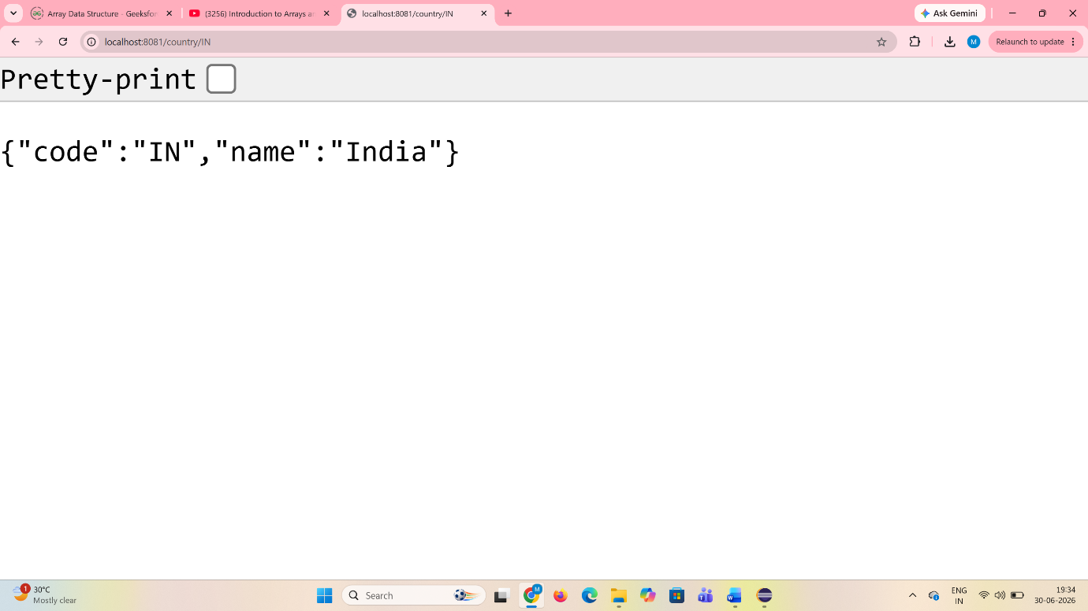
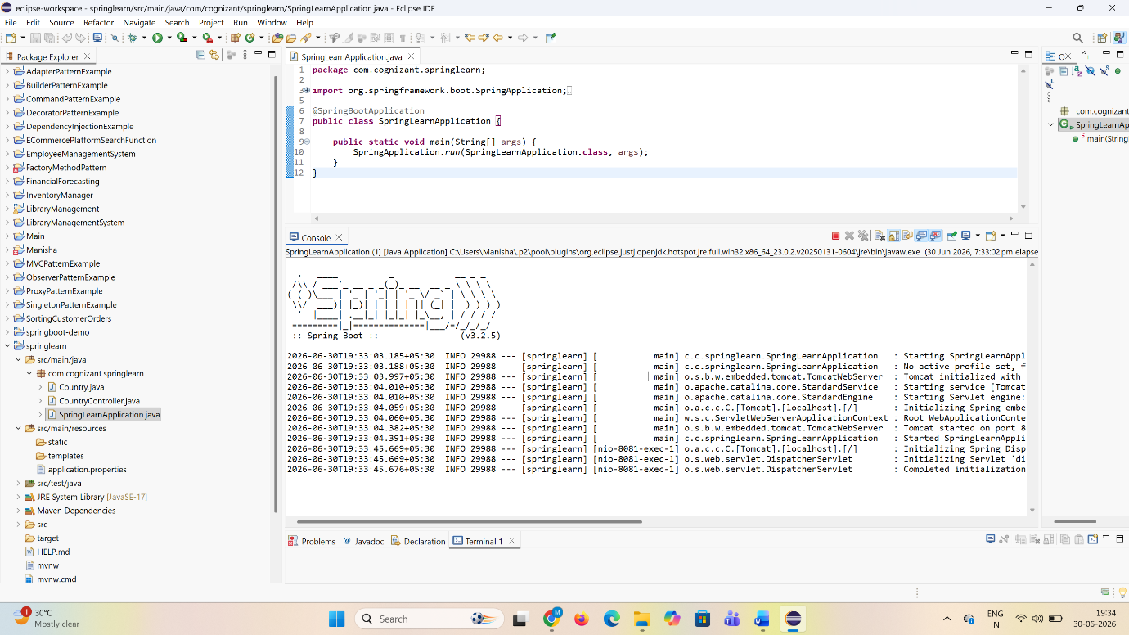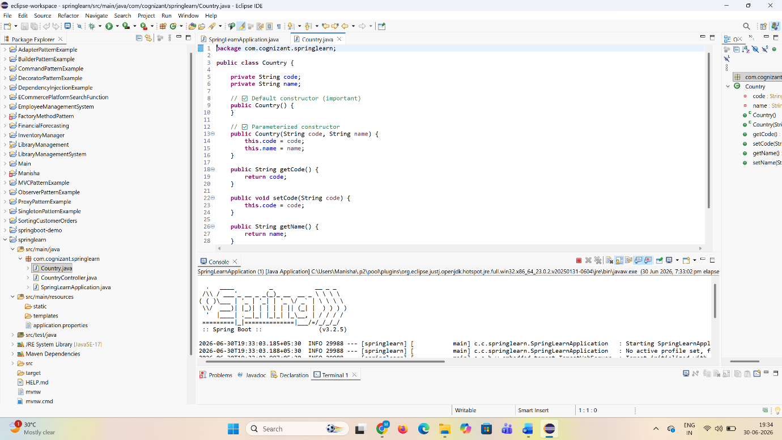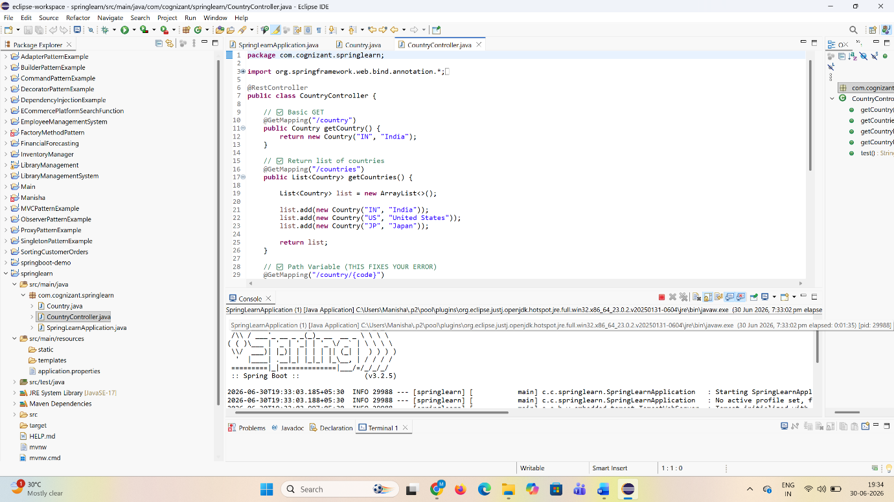

- Demonstrate implementation of end to end testing of RESTful Web Service using MockMVC
  - @AutoConfigureMockMvc, MockMvc, @Test, get(), perform(), andExpect(), status().isOk(), jsonPath().exists, jsonPath().value(), status().isBadRequest(), status().reason test execution in Eclipse, test execution in command line using maven
    - Server Side Testing - https://docs.spring.io/spring/docs/5.1.9.RELEASE/spring-framework-reference/testing.html#spring-mvc-test-server

